How do I change my Headquarters server IP address without re-installing the Shoretel build?

Answer
You need to log on to Director and amend the IP address for the server: Application Servers/Platfrom Equipment:
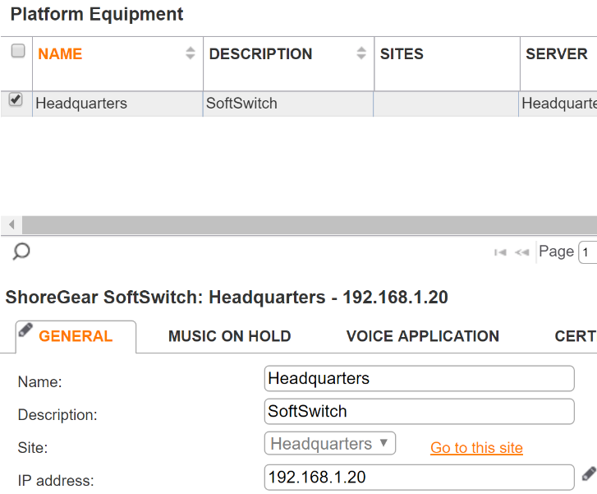

- Next, there are 2 registry keys that need to be changed:
To make these changes, open a Command Prompt, run regedit and browse to:

HKEY_LOCAL_MACHINE\SOFTWARE\Shoreline Teleworks\HQServerAddress
and
HKEY_LOCAL_MACHINE\SOFTWARE\Shoreline Teleworks\LocalDBServerAddress
- Change the values to the new server IP address
- Change the network card IP address to the new server IP address

Note
On systems 14.2 and above, the Diagnostics and Monitoring (14.2) or Dashboard (Connect) will not show any data unless the following configuration file is also amended to the new server IP address:

Browse to:
C:\Program Files (x86)\Shoreline Communications\ShoreWare Server

Locate the Monitoringservice.ini file. Open with Notepad, amend the server IP address and save.

Now reboot the server and it should come back online with the new IP address.

